DECIMAL TO BINARY

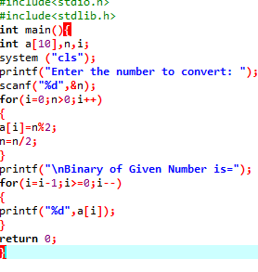

OUTPUT

